Calibration Summary: Alouette Lake

Basin Info
Location | 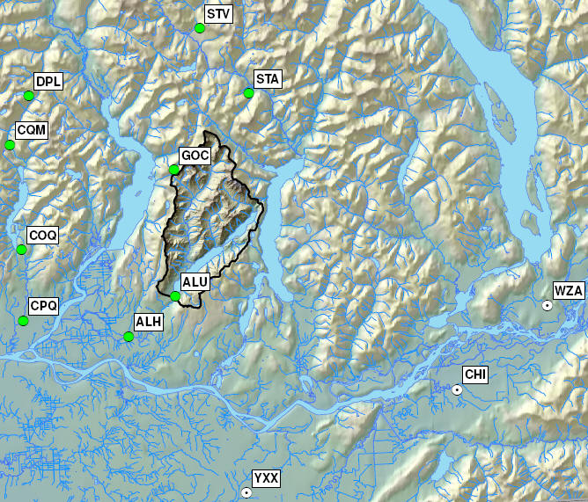
Drainage area | 201.9 km²
Elevation | Min | 114 m |  |  | Max | 2055 m
Glaciated Area | 2.9 km² (1.4%)
Hypsographic Curve | 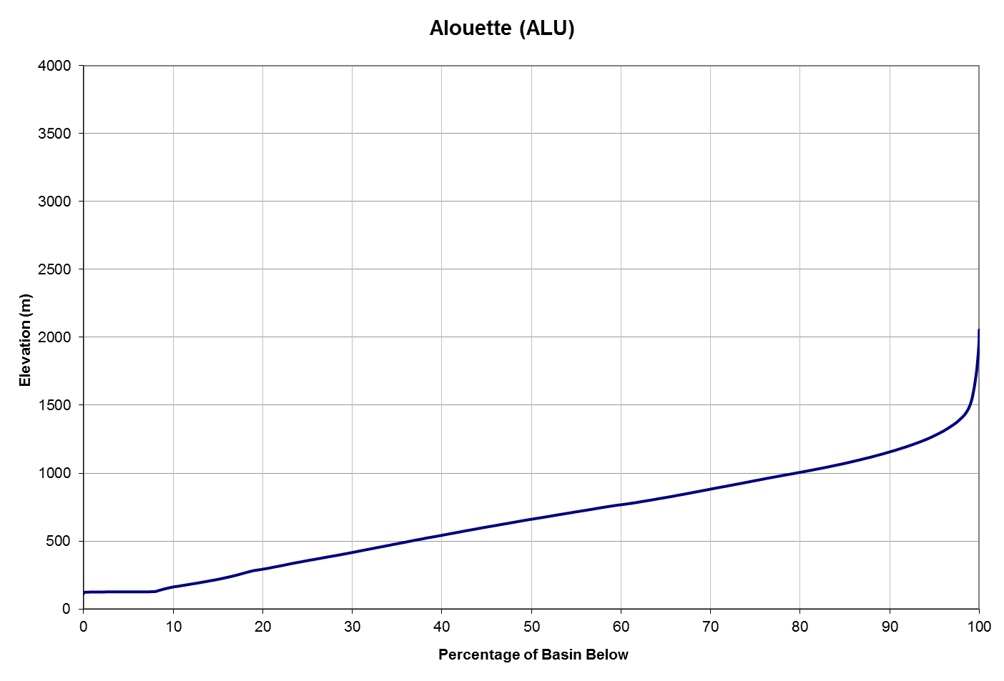
Avg. Annual Precipitation ¹⁾ | 4042 mm (PRISM: 3377 mm) |  |  | Avg. Annual Snowfall ¹⁾ |  |  |  | 547 mm (14% P)
Avg. Annual Runoff | 3385 mm (22 m³/s ; 84% P) |  |  | Avg. Glaciermelt Runoff ¹⁾ |  |  |  | 61 mm (1.8% Q)
Avg. Annual Hydrograph / Hyetograph | 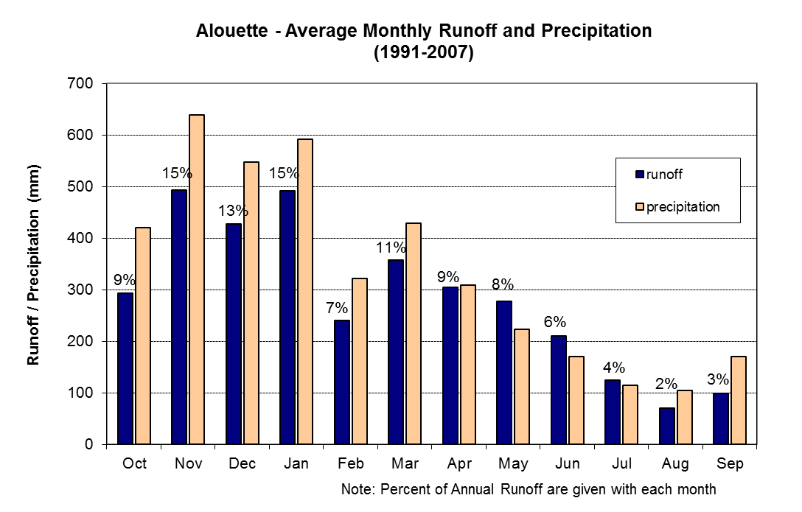
Normal Runoff (1971-2000) | Month |  | Inflow (cms) |  |  |  | Inflow (10⁶ m³)
Normal Runoff (1971-2000) | Jan |  | 28.4 |  |  |  | 76.0
Normal Runoff (1971-2000) | Feb |  | 24.9 |  |  |  | 60.9
Normal Runoff (1971-2000) | Mar |  | 22.9 |  |  |  | 61.4
Normal Runoff (1971-2000) | Apr |  | 22.1 |  |  |  | 57.3
Normal Runoff (1971-2000) | May |  | 24.0 |  |  |  | 64.4
Normal Runoff (1971-2000) | Jun |  | 18.9 |  |  |  | 48.9
Normal Runoff (1971-2000) | Jul |  | 11.9 |  |  |  | 31.9
Normal Runoff (1971-2000) | Aug |  | 5.6 |  |  |  | 15.1
Normal Runoff (1971-2000) | Sep |  | 8.5 |  |  |  | 21.9
Normal Runoff (1971-2000) | Oct |  | 20.5 |  |  |  | 55.0
Normal Runoff (1971-2000) | Nov |  | 37.4 |  |  |  | 97.0
Normal Runoff (1971-2000) | Dec |  | 32.0 |  |  |  | 85.7
Runoff Regime | Hybrid
Main Tributaries | None
Best Reference Stream (R²) | North Alouette River at 232nd Street (WSC 08MH006 ; R² = 0.91)

Notes 1) Estimated from UBC watershed model

Calibration Info
Calibration Period | 1991-2007
Verification Period | 1987-1991
# of Elevation Bands | 7
Temperature Data  - Band assignment  - Filename  - Composition  - Station 1  - Station 2  - Station 3  - TS ID | [All bands]  ALUComp.ADC  0.33 ALU + 0.33 CQM + 0.33 GOC  Alouette Forebay DCP (ALU; 125 m)  Coquitlam River above Coquitlam Lake DCP (CQM; 290 m)  Gold Creek DCP (GOC; 794 m)  100000.1/102.00/314 (312)
Precipitation Data  - Band assignment  - Filename  - Composition  - Station 1  - Station 2  - Station 3  - TS ID | [All bands]  ALUComp.ADC  0.48 ALU + 0.38 CQM + 0.15 GOC  Alouette Forebay DCP (ALU; 125 m)  Coquitlam River above Coquitlam Lake DCP (CQM; 290 m)  Gold Creek DCP (GOC; 794 m)  100000.1/110.00/315
Flow Data  - TS ID | 100000.1/110.00/315
Parameters  - Filename  - Date | ALU.wat  Jun 27, 2012
Time Constants  - Fast runoff -rain  - Fast runoff - snowmelt  - Fast runoff - glacier  - Interflow - rain  - Interflow - snowmelt  - Upper groundwater  - Deep groundwater | 0.16 days  0.33 days  0.39 days  0.57 days  1.3 days  16.5 days  60.3 days
Folder Name | J:\PS\pso\Hydrology\UBCWM calibration 2008\results\FINAL\ALU
Modeler | S. Weston

Best-of-ensemble Parameter Set Performance Statistics
Daily  Nash-Sutcliff | Monthly  % volume error |  |  |  |  |  |  |  |  |  |  |  | Yearly  % volume error
 | Jan | Feb | Mar | Apr | May | Jun | Jul | Aug | Sep | Oct | Nov | Dec
2001 calibration, total period (Oct 1 1984 to Sep 30 1998)
0.73 | -20.0 | -7.2 | -8.8 | -1.0 | 3.3 | 5.1 | 18.2 | 57.5 | 127.5 | 27.1 | -6.3 | -9.9 | 1.0
Absynthe, total period (Oct 1 1987 to Sep 30 2007)
0.83 | -10.6 | 4.3 | -0.6 | 3.9 | 7.6 | -5.1 | -5.7 | 15.4 | 8.9 | 11.7 | 4.2 | -6.3 | 0.8
Absynthe, calibration period (Oct 1 1991 to Sep 30 2007)
0.84 | -8.9 | 7.4 | 1.2 | 8.3 | 4.6 | -8.6 | -5.7 | 9.3 | 2.7 | 7.2 | 2.9 | -8.9 | 0.1
Absynthe, validation period (Oct 1 1987 to Sep 30 1991)
0.78 | -19.9 | -4.9 | -10.8 | -10.3 | 17.9 | 7.5 | -5.8 | 29.1 | 46.6 | 35.4 | 8.2 | 6.8 | -1.0

Comments

Additional Documentation
- J:\PS\pso\Hydrology\UBCWM calibration 2008\results\ALU \Alouette2008RecalibrationResults_V2.doc
- J:\PS\pso\Hydrology\UBCWM calibration 2008\documents\UBCWM Recalibration Roadmap\ UBCWM_RecalibrationRoadmap_2ndDRAFT_v1.doc
- J:\PS\pso\Hydrology\UBCWM calibration 2008\documents\UBCWM Recalibration Roadmap\ UBCWM_RecalibrationRoadmap_JULY2008-ADDENDUM_v7.doc
- Scott – DMC analysis
- Scott – GIS analysis

Calibration reviewed by: F. Weber
Date: Oct 20, 2008

